## Divide Little League

Divide Little League

2025 Safety Plan

League ID 405-54-18

**Luke Elliott, President**

530-401-1607

**Lacey Polte, Safety Officer**

530-295-7038

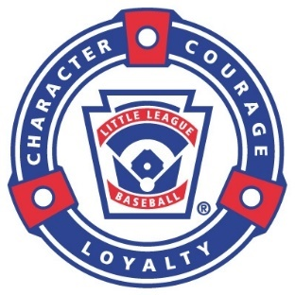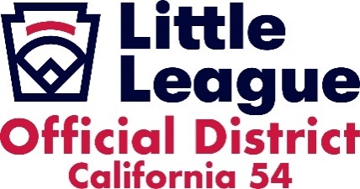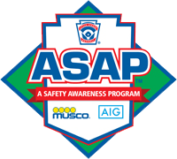

Contents

Divide Little League 5

Mission Statement 5

Safety Message 5

Safety Plan 6

Divide Little League Board of Directors 7

Emergency Action Plan 8

Important Local Emergency Phone Numbers: 8

Procedure for Emergency Calls 8

Divide Little League Safety Officer 9

Divide Little League Safety Code 10

First Aid / Safety Training 11

First Aid 11

First Aid Do and Don'ts 11

Common injuries 12

Concussion protocol 13

Sudden Cardiac Arrest (SCA) protocol 14

Injury Reporting 15

What to Report 15

When to Report 15

How to Report 15

Injury Prevention 17

Nutrition and Hydration 17

Elbow and shoulder injuries 18

Pitch Counts 19

*A pitcher who delivers 41 or more pitches in a game can not play the position of catcher for the remainder of the day. 19

Equipment 20

Head and facial injuries 20

Volunteer Application 21

Codes of Conduct 21

Manager & Coach Responsibilities 21

Preseason Responsibilities 22

Season Play 22

Pre-Practice and Game Responsibilities 23

Responsibilities During the Game 23

Post-Game Responsibilities 24

Fundamentals Training 24

Warming Up / Stretching 24

Warm Up to Throw, DON’T Throw to Warm Up 24

Equipment 25

Equipment 25

Equipment Checkout and Return 25

Divide Little League Fields and Facility Survey 25

Field Inspections 26

DLL Field Locations 26

Golden Sierra Field 26

Georgetown School Field 26

First Aid Kits 27

Team Folders 27

Concessions 27

Enforcement of Little League Rules 28

Weather Procedures 28

Thunder and Lightning 28

Heat/Air Quality 28

Wildlife on the Field 29

Rattlesnakes 29

Mountain lions, bears, aggressive dogs, etc. 29

List of Appendices 30

Appendix A – Sample Safety Training Certificates 31

Appendix B – Allergic Reactions, Anaphylaxis, and EpiPen Administration Instructions 32

Appendix C – Parent/Athlete Concussion Information 34

Appendix D – Sudden Cardiac Arrest Prevention Information 36

Appendix E – Incident/Injury Tracking Report Form 38

Appendix F – Little League Accident Notification Form 39

Appendix G – Little League Volunteer Application 40

Appendix H – Divide Little League Codes of Conduct (Player, Parent, Manager/Coach) 41

Appendix I- Medical Release Form 44

Appendix J- Safety Clinic Flyer 45

Appendix K – Big Al Baseball Online Training 46

Appendix L – Baseball/Softball Dynamic Warm-Up and Stretching Program (from University of Rochester Sports Medicine) 47

Appendix M – Concussion: Signs, Symptoms and Action Plan 55

Appendix N – Concession Stand Rules and Safety Tips 56

Appendix O - Lightning Safety Procedures 58

Appendix P – References, Links and Websites 59

## Divide Little League

Mission Statement

The mission of the Divide Little League shall be to implant firmly in the children of the community the ideals of good sportsmanship, honesty, loyalty, courage and respect for authority, so that they may be well adjusted, stronger and happier children and will grow to be good, decent, healthy and trustworthy citizens.

## Safety Message

DLL is excited to welcome our league members to another fun and exciting year of Divide Little League Baseball! DLL’s highest priority continues to be the safety of our players and their families. To fulfill our mission of providing a safe playing environment any and every time our teams take the field, we need the commitment of every single member of our league. The first step of that commitment is to review the DLL Safety Plan. The purpose of the DLL Safety Plan is to outline the safety policies and procedures of our league, which are intended to create, encourage, and maintain the highest standards of safe play at all levels. Please remember that the responsibility of safety rests with each of us, the volunteers of Divide Little League. Since prevention is the key to reducing accidents and injuries, we ask that you always use common sense, always believe what children tell you, and always report accidents if they occur. From the entire Board of Directors, we thank you for your time and commitment to the Divide Little League program. Have fun and always remember safety first!

# Safety Plan

The Divide Little League Safety Plan is an annual requirement of Little League International’s A Safety Awareness Program (ASAP). It includes the 15 elements required by ASAP (listed below), along with the safety policies and procedures specific to Divide Little League:

1. Safety Officer
2. Safety Manual Distribution
3. Emergency Plan
4. Volunteer Application
5. Fundamentals Training
6. First Aid Training
7. Check Field Conditions
8. Facility Survey
9. Concession Stand Safety
10. Equipment Check
11. Accident Reporting
12. First Aid Kits
13. Enforce Little League Rules
14. Player / Coach Data
15. Survey Questions

All league members are encouraged to review the safety plan annually. Divide Little League expects all members to adhere to all safety policies and procedures and to assist the league in creating a culture of safety.

The Safety Plan will be posted on our website and emailed to all Managers and Coaches. All teams will have a printed copy of the ASAP and there will be a copy in all sheds. If there are any questions contact the Safety Officer or President.

# Divide Little League Board of Directors

|  |  |  |  |
| --- | --- | --- | --- |
| Position | Name | Phone | Email |
| President | Luke Elliott | 530-401-4398 | dividelittleleague@gmail.com |
| Vice President | Blake Braafladt | 916-290-2891 | dividelittleleaguevp@gmail.com |
| Secretary | Rose Olsen | 530-748-5659 | dividelittleleaguesecretary@gmail.com |
| Treasurer | Jessica Langenegger | 916-271-4067 | dividelittleleaguetreasurer@gmail.com |
| Safety Officer | Lacey Polte | 530-295-7038 | dividesafety@gmail.com |
| Player Agent | Steve Jenkins | 650-834-1329 | divideplayeragent2@gmail.com |
| Coaching Coordinator | Brent Benzer | 925-325-7890 | divideoachcoordinator@gmail.com |
| Umpire in Chief | Jeremy Yergler | 916-417-3238 | divideumpire@gmail.com |
| Equipment Manager | Tyson Polte | 503-748-6032 | divideequipment@gmail.com |
| Field Maintenance Manager | Dan Trahan | 530-368-9114 | dividefields@gmail.com |
| Scheduler/Information Officer | Kati Jardine | 530-417-0374 | dividescheduler@gmail.com |
| Uniforms Manager | Ann Dorsey | 916-477-9883 | divideuniforms@gmail.com |
| Sponsorship/Fundraising Manager | Tyler Anderson | 916-743-6341 | dividesponsorship@gmail.com |

# Emergency Action Plan

**In case of a medical emergency, call 911.**

## Important Local Emergency Phone Numbers:

|  |  |  |
| --- | --- | --- |
| **El Dorado County Sheriff** | Emergency Number | 911 |
| Non-Emergency Number | (530) 621-6600 |

## Procedure for Emergency Calls

The most important help that you can provide a victim that has been seriously injured is to call for professional medical help. Make the call quickly, preferably from a cell phone near the injured person. If this is not possible, send someone else to make the call from a nearby telephone. Be sure that you or another caller follow these important steps:

* Dial 9-1-1 from a cell phone.
* Give the dispatcher the necessary information:
  + Identify yourself.
  + Your location: which field and the address
  + The age of the injured person.
  + What is the emergency/injury and how it happened.
  + The condition of the injured person ex: unconscious, chest pain, severe bleeding, etc.
  + What help is being provided (first aid).
  + Don’t hang up until the dispatcher tells you to. The EMS dispatcher may be able to tell you how to best care for the victim.
  + Continue to care for the victim until professional help arrives.
  + **IMPORTANT**: appoint someone (or several people) to go to the street and look for the Fire Department and Ambulance and direct them to the injured person.

# Divide Little League Safety Officer

**Lacey Polte** is the Safety Officer for DLL and is a member of the DLL Board of Directors. She can be contacted at 530-295-7038 or dividesafety@gmail.com.

The responsibilities of this position are developing and implementing DLL’s safety program per Little League’s A Safety Awareness Program (ASAP) and reviewing all league operations with a focus on safety. Safety is the primary objective when placing players in the appropriate division per their skill level, for themselves and for others.

The Safety Officer’s responsibilities include (but are not limited to):

* Attend safety meetings with the District 54 Safety Officer and provide input from the league level.
* Ensure DLL maintains a copy of the league’s insurance policy.
* Help the President with background checks and fingerprinting for manager and coach candidates, board members, and other appropriate DLL volunteers if needed.
* Maintain record of and follow up on all injury reports (see Injury Reporting).
* Track all injuries and near misses to identify injury patterns that may be amenable to education and/or prevention strategies.
* Coordinate annual safety/first aid training for all managers and coaches.
* Distribute the Safety Plan manual to each team manager at the beginning of the season and place copies in all field sheds.
* Stock and provide a first aid kit for each team and field replenishing contents throughout the season as necessary.
* Ensure that safety is a monthly Board Meeting topic and encourage experienced individuals to share ideas on improving safety.
* Perform and document the annual survey and analysis of playing fields and facilities with the Field Maintenance Manager, President, and other appropriate board members, and communicate the results to the board, especially areas/issues that require attention.
* When unsafe or hazardous conditions are identified and brought to the attention of the safety officer, they will act immediately to resolve the issue, working with the DLL board and the Field Maintenance Manager.

# Divide Little League Safety Code

Little League rules, the DLL Safety Manual, and the following Safety Code for Little League, as adapted from the Little League Rulebook, will be enforced at all league activities:

* Managers, coaches, and umpires should have some training in first aid.
* Every manager will be issued a first aid kit and it should be available at every Little League practice and game.
* No games or practices should be held when weather or field conditions are not good, particularly when lighting is inadequate.
* Play areas should be inspected frequently for holes, damage, glass, and other foreign or hazardous objects.
* Dugouts and bat racks should be positioned behind screens.
* Only players, managers, coaches, and umpires are permitted on the playing field during play and practice sessions.
* Responsibility for keeping bats and loose equipment off the field of play should be that of a regular player assigned for this purpose, or the manager and coaches.
* Procedure should be established for retrieving foul balls batted out of the playing area.
* During practice sessions and games, all players should be alert and watch the batter on each pitch.
* During warm up drills, players should be spaced so that no one is endangered by errant balls.
* Equipment should be inspected regularly. Make sure it fits properly.
* Pitching machines, if used, must be in good working order (including extension cords, outlets, etc.) and must be operated only by adult managers and coaches.
* Batters must wear protective NOCSAE helmets during practice, as well as during games.
* Catchers must wear a catcher's helmet (with face mask and dangling throat guard), chest protector, and shin guards. Male catchers must wear a protective supporter and cup at all times. NO EXCEPTIONS.
* Except when a runner is returning to a base, head-first slides are not permitted. This applies only to Little League (Majors), Minor League, and Tee Ball.
* During sliding practice, bases should not be strapped down.
* At no time should “horse play” be permitted on the playing field.
* Parents of players who wear glasses should be encouraged to provide “Safety Glasses.”
* Players must not wear watches, rings, pins, jewelry, hard cosmetic, or hard decorative items.
* Catchers must wear a catcher’s helmet, face mask and dangling throat guard when warming up pitchers. This applies between innings and in bullpen practice. NO EXCEPTIONS.
* Batting/catcher’s helmets should not be painted unless approved by the manufacturer.
* Regulations prohibit on-deck batters. This means no player should handle a bat, even while in an enclosure, until it is his/her time at bat. This applies only to Little League (Majors), Minor League, and Tee Ball.
* Players who are ejected, ill, or injured should remain under supervision until released to the parent or guardian.

# First Aid / Safety Training

DLL will deliver safety/first aid training to managers/coaches on February 3rd, 2025 at 6:00PM (Location TBD). The District 54 safety clinic recording will be an option for leagues to use for safety training.

All managers, coaches, board members, and adult umpires are required to complete the following safety trainings (junior umpires, less than 18 years old, are strongly encouraged to complete):

1. [Online Concussion Training](https://www.cdc.gov/headsup/youthsports/training/index.html), through CDC Heads Up
   * <https://www.cdc.gov/headsup/youthsports/training/index.html>
2. [Sudden Cardiac Arrest (SCA) Prevention Training](https://epsavealife.org/sca-prevention-training/), via Eric Paredes Save a Life Foundation
   * <https://epsavealife.org/sca-prevention-training/>
3. Child Protection Program Training (through SafeSport), [Abuse Awareness for Adults](https://www.littleleague.org/player-safety/child-protection-program/safesport-resources-parents/)
   * <https://www.littleleague.org/player-safety/child-protection-program/safesport-resources-parents/>
   * Must be completed by ALL VOLUNTEERS, in addition to those listed above.

# First Aid

## First Aid Do and Don'ts

DO…

* Reassure a child who is injured, sick, frightened, or lost.
* Ask permission before providing first aid.
* Know your limitations.
* Managers carry with you or know the location of a first aid kit to all practices and games.
* Managers have all player medical release forms with you at all practices and games.
* Always have a cell phone available at all practices and games.
* Report hazardous conditions to the Safety Officer or other board member immediately.

DON’T…

* Administer any medications.
* Apply ice packs directly to skin. Wrap in a towel or apply over clothing.
* Provide food or beverages other than water.
* Be afraid to ask for help.
* Leave an unattended child at a practice or game.
* Hesitate to report any present or potential safety hazards to the Safety Officer or other board member.

## Common injuries

**Contusions**

* Result from a direct blow from a ball or player.
* There is swelling and discoloration from bleeding under the skin.
* Treat with ice and compression. Players are usually able to return to play the same day unless there is pain with bearing weight or with moving a joint (see musculoskeletal injuries below).
* **Note on applying ice**: do not apply ice or an ice pack directly to the skin. Wrap it in a towel or a shirt or apply over clothing. In the first 2-3 days after an injury, apply ice for 10 minutes every hour (at the most). After that, it may be applied 10-15 minutes, up to 3 times a day.

**Abrasions**

* Abrasions of the skin include small cuts, scrapes, turf burn, etc.
* Always use universal precautions when caring for wounds (gloves, etc.)
* Gently cleanse the wound with clean water to remove any debris. Allow to dry. Apply a clean dressing to keep wet areas covered. See Little League rules regarding blood on uniforms and equipment (Little League Rules, Appendix C: Communicable Disease Procedures).

**Bloody Nose**

* To control a nosebleed, have the player sit, lean forward slightly, and pinch the nostrils closed for 5 minutes.
* If the nosebleed has not stopped after 15 minutes, the player should be medically evaluated.
* There is no evidence to support using ice packs on the back of the neck to stop bleeding from the nose.

**Musculoskeletal injuries**

* Children and adolescents are not small adults. As they grow, their soft tissues (muscles, ligaments, tendons and fascia) are stiff and weak, which is a recipe for injury.
* The growth plates in the elbow and shoulder do not close until about age 15-17 in boys and about age 14-16 in girls. The growth plates are extremely vulnerable to injury from overuse and rotational forces like throwing. Growth plate injuries require appropriate treatment to avoid lifelong issues with the corresponding bone or joint.
* **Players should not play through any pain, especially in the shoulder or elbow, as this may signal a growth plate injury.**
* For other musculoskeletal injuries, if there is swelling, pain with bearing weight, pain with moving the joint or limited movement of the joint, then medical evaluation is recommended prior to returning to play.

**Heat illness**

* Children and adolescents, again, are not small adults. They produce more heat with activity and are not able to cool themselves as well as adults (as was previously discussed). Thus, children and adolescents can overheat very quickly **and** in any type of weather.
* When it is hot, provide frequent water breaks (every 15 minutes) in the shade. Water is sufficient for hydration unless the activity is intense and lasts more than 60 minutes.
* Players should have their own water bottle labeled with their name. **No sharing of water bottles will be allowed.**
* Players who are overheated should rest and hydrate until they feel well enough to rejoin the activity.
* **If symptoms progress to vomiting or confusion, this is heat stroke and is a medical emergency. Call 9-1-1 right away and begin cooling procedures IMMEDIATELY.**

**Anaphylaxis / Allergic reactions**

* Some people/players may have serious allergic reactions to things like bees or peanuts. **Managers and coaches need to know if any players on their team have a serious allergy and if they carry an EpiPen.**
* **If you suspect a player is having an allergic reaction, administer an EpiPen if one is on hand (see Appendix B for instructions) and call 9-1-1. The longer you wait to administer an EpiPen, the harder it is to stop an allergic reaction.**
* For moderate symptoms after a bee sting, try to remove the stinger by gently scraping with a fingernail or business card and apply ice to the area.

**Dental Injuries**

* Control the bleeding in the mouth by gently biting on a towel. This will also help stabilize the tooth.
* If the tooth is broken or knocked out completely, first find the tooth or broken piece, then rinse it and store in milk or inside the cheek for transport to the dental office.
* **IMMEDIATELY** transport the player and the tooth to the dentist.

## Concussion protocol

The State of California requires all coaches/managers and administrators (board members and umpires) of youth sports to complete concussion training annually. DLL requires manager/coaches, umpires and the Board of Directors to complete the Heads Up Concussion In Youth Sports training provided by the Centers for Disease Control (CDC) and successfully pass the concussion evaluation quiz. **Successful completion of this training is required every year.** The course can be accessed online at:

[***https://www.cdc.gov/headsup/youthsports/training/index/html***](https://www.cdc.gov/headsup/youthsports/training/index/html)

DLL provides all registrants with the CDC Heads Up Concussion Information Sheet and requires players and parents/guardians to complete the concussion information acknowledgement form (Appendix C), as required by California state law.

A concussion is an injury to the brain resulting from a direct blow to the head or a direct blow to the body with transmission of force to the head. Common symptoms of concussion in adolescents are headache, dizziness, fogginess, unsteadiness and possibly nausea, vomiting or vision changes. If a player is suspected to have sustained a concussion injury, they should be removed from play and not allowed to return that day. **When in doubt, sit them out.**

**After a player is removed from the field of play due to a suspected concussion,** **the decision about when to** **return to the field can only be made, per California law, by a health care professional qualified to make such a decision**. **The California Interscholastic Federation (CIF) specifies that this professional must be a physician (M.D. or D.O.).** **Therefore, DLL requires a written doctor’s note be submitted to the manager AND Safety Officer clearing the player before allowing a player to return to practice/play**.

## Sudden Cardiac Arrest (SCA) protocol

The State of California requires all coaches/managers and administrators (board members and umpires) of youth sports to complete sudden cardiac arrest (SCA) prevention training annually. DLL requires manager/coaches, umpires and the Board of Directors to complete SCA prevention training through the Eric Paredes Save A Life Foundation. **Successful completion of this training is required every year.** The course can be accessed online at:

[***https://epsavealife.org/sca-prevention-training/***](https://epsavealife.org/sca-prevention-training/)

DLL provides all registrants with the Eric Paredes Save A Life Foundation’s SCA Fact Sheet for Parents & Student Athletes and requires players and parents/guardians to read and sign the SCA information acknowledgement form, as required by California state law (Appendix D).

Sudden Cardiac Arrest (SCA) is not the same as a heart attack. It is caused by a malfunction in the heart’s electrical system or structure due to an abnormality the person was born with or inherited, or it can develop as they grow. Players, parents/guardians, managers, coaches and adult volunteers should all be familiar with the following symptoms. If a player has any of these symptoms, they should tell an adult and see their physician right away:

* Fainting or seizure, especially during or right after exercise.
* Fainting repeatedly or with excitement or startle.
* Racing heart, palpitations, or irregular heartbeat.
* Dizziness or lightheadedness.
* Chest pain or discomfort with exercise.
* Excessive shortness of breath during exercise.
* Excessive, unexpected fatigue during or after exercise.

**In the event of a possible cardiac arrest, follow the cardiac chain of survival:**

* **Call 9-1-1 and immediately begin CPR. Immediate and continuous application of CPR can triple the chance of survival.**
* **Find and apply an AED, if available.**
* **Continue CPR (and AED use, if available) until emergency medical services arrive.**

# 

# 

# Injury Reporting

Managers and coaches will review DLL’s injury reporting procedures during the preseason meeting, as described below.

## What to Report

We cannot eliminate all injuries or accidents, but we can use them to identify the cause so something can be done to prevent occurrence, or at the very least, recurrence. Good judgment should be used when deciding which accidents and near misses to report for analysis. The severity of an injury is a consideration; however, it is not the only factor that should determine what incidents need to be reported. Examples of accidents that require follow-up and analysis include:

* Two players going after the same fly ball collide. A player trips and falls over a bat left on the field. Even if no one is hurt, these situations could result in serious injury. Corrective measures can be taken by coaches to address field assignments, practice appropriate techniques and review the appropriate placement of equipment. An incident report submitted to the Safety Officer will serve as a warning to managers of other teams.
* A player is injured chasing a fly ball and when the outfield is inspected, a hole is found in right field. An incident report will trigger immediate corrective action and review of other fields for safety.

When an injury is severe enough to require professional services, the need for corrective measures is obvious. It is also imperative that the Safety Officer have accurate information about the injury or incident to complete the insurance claim report. Incident reports also facilitate communication between teams in a league and leagues in a district. This sharing of information enables league Safety Officers and the District Safety Officer to ensure the effectiveness of all safety programs.

## When to Report

**All injuries must be reported to the DLL Safety Officer within 24 hours of the incident.** If the injury occurred while playing at another league’s field, the DLL Safety Officer should likewise be informed, and they will then notify the home league’s safety officer.

## How to Report

Divide Little League Injury

Reporting QR code



All first aid kits will have a QR code card that can be scanned to report an injury. Scanning the QR code will bring you to a google form that will need to be filled out and submitted. The Safety Officer will get the report and complete the Little League Incident/Injury tracking form. The Safety Officer will send a copy of the Incident/Injury Tracking Report form to the District 54 Safety Officer, per the district safety plan, and maintain the original on file.

If an injury/accident sustained during a Little League activity required professional medical attention, parents/guardians of the injured player are required to complete a copy of the Little League Accident Notification form (See Appendix F). This form must be completed by parents/guardians (if claimant is under 19 years of age) and a league official (the Safety Officer) and forwarded to Little League Headquarters within 20 days of the accident.

**Any player who is removed from play for a suspected concussion, who requires professional services for an injury, or who is out of play for 7 days or more due to an injury must present a written clearance note from a physician to the Safety Officer to return to practice or games.**

The DLL Safety Officer provides a monthly safety and injury report to the Board of Directors. Collective injury information is de-identified and analyzed for patterns and/or issues that require corrective measures and presented to the board for discussion and implementation of appropriate actions to prevent future issues. Similarly, the District 54 Safety Officer presents collected and de-identified injury information to the district staff and league presidents at their monthly meetings for similar action.

# Injury Prevention

The following are general principles for injury prevention:

* Taking time off to rest at least one day per week and one month per year is important for young athletes.
* Wearing appropriate and properly fitted protective equipment: in the case of baseball, that would be helmets, sport cups, padding, catcher’s gear, etc. Players should be reminded that they are not invincible when wearing it.
* Regular conditioning exercises to strengthen the muscles used in play: practice makes permanent!
* Stretching regularly after games and practice can increase overall flexibility.
* Reinforce proper technique throughout the season.
* Dynamic warm-up is recommended prior to activity (see page 24). Dynamic movements are gentle, repetitive movements that gradually increase range of motion. **Evidence strongly suggests that pre-exercise static stretching does not reduce the risk of injury. Muscle injuries occur when the muscle is not strong enough or does not contract at the right time.**
* Take breaks! For water and for fun to break things up during a session.
* Play by the rules: they are intended to keep players safe.
* Do not allow players to play through pain.

## Nutrition and Hydration

When children and adolescents are physically active, their muscles generate heat, which increases their body temperature. One of the body’s natural cooling responses to increased body temperature is sweat. When sweat evaporates, the body is cooled. Unfortunately, children get hotter than adults during physical activity and their body’s cooling mechanism is not as efficient as adults. If fluids are not adequately replaced, children can quickly become overheated. We usually think about dehydration in the summer months when hot temperatures shorten the time it takes for children to become overheated. But keeping children well hydrated is just as important in the winter months. Additional clothing worn in the colder weather makes it difficult for sweat to evaporate, so the body does not cool as quickly. Whether it is January or July, thirst is not an indicator of fluid needs. **Always encourage children to drink fluids, even when they do not feel thirsty.** Managers and coaches should schedule water breaks every 15 to 30 minutes during practices on hot days and should encourage players to drink between every inning during games.

**Water is the best fluid for hydration.** The American Academy of Pediatrics says that most children need only water to hydrate during and after sports. Sports drinks just add a lot of extra calories (plus sugar and dyes). The average 8-year-old burns only 150 calories in an hour of sports and children can replenish electrolytes at the next meal.

Adolescence is the perfect time to teach athletes how to effectively fuel their body for training, competition, and recovery. Some excellent tips are listed in the table below, from the article [“Fueling and Hydrating Before, During and After Exercise,”](https://www.nationwidechildrens.org/specialties/sports-medicine/sports-medicine-articles/fueling-and-hydrating-before-during-and-after-exercise) from the Nationwide Children’s Sports Medicine website.

|  | **Before Exercise** | | **During Exercise** | | **After Exercise** | |
| --- | --- | --- | --- | --- | --- | --- |
| **When** | 3-4 hrs before | 30-60 min before | Exercise lasting <60 min | Exercise lasting >60 min | 15-60 min after | 2-3 hrs after |
| **Nutrition Recommendations** | Meal: high carb, moderate protein, low fat & fiber | Snack: carb |  | Snack: carb | Snack: Carb & protein | Balanced meal: carb, protein & fats |
| **Hydration Recommendations** | 8-20 oz fluid 1 hour before exercise | | None or water | 4-6 oz fluid every 15 min | Rehydrate with 16-24 oz fluid per one pound lost through sweat | |
| **Examples** | * Lunch meat and cheese sandwich * Grilled chicken, rice, vegetables * Spaghetti and meatballs | * Peanut butter sandwich * Pretzels and peanut butter * Trail mix and banana |  | * Sports drink * 100% fruit juice * Orange * Banana * Granola bar | * Chocolate milk * Cheese & crackers * Protein bar * Smoothie * Yogurt & granola | * Hamburger & grilled vegetables * Salmon, mixed vegetables & rice * Pizza & salad * Lasagna |

## Elbow and shoulder injuries

The role of parents and coaches in injury prevention is crucial. A 2015 study found that 46% of youth baseball respondents said they were encouraged on at least one occasion to keep playing despite having arm pain.[1] When a child complains of arm pain, adults MUST act in the best interests of the child. Risk factors for elbow pain in baseball/softball include:

* + Pitching while fatigued.
  + Poor pitching mechanics.
  + Pitch velocity.
  + Pitch counts (120 to 130-140 per game).

Prevention strategies include limiting fatigue and overuse by following pitching/throwing guidelines (see below), taking periodic time off from baseball/softball, and using age-appropriate strength and conditioning programs (consult a professional). Players should maintain range of motion throughout the body and the shoulder. And remember, Warm up to throw, don’t Throw to warm-up! (see Dynamic Warm-up on page 25).

## 

## 

## Pitch Counts

Divide Little League takes pitch counts very seriously because studies show that adhering to league age pitch counts is a very effective injury prevention strategy. Scorekeepers for the Minor, Major, and Junior divisions keep track of pitch counts during games; managers must be aware of pitch counts during games to ensure their players are not exceeding their maximum number of pitches per day.

League age pitch counts for Little League Baseball are as follows:

|  |  |
| --- | --- |
| **League Age** | **Maximum # pitches per day** |
| 13-16 | 95 pitches per day |
| 11-12 | 85 pitches per day |
| 9-10 | 75 pitches per day |
| 7-8 | 50 pitches per day |

Similarly, pitch count thresholds and associated required rest days are an integral part of preventing injuries:

|  |  |  |  |
| --- | --- | --- | --- |
| **League age 14 and under** | | **League age 15-16** | |
| 66+ pitches | 4 days rest | 76+ pitches | 4 days rest |
| 51-65 pitches | 3 days rest | 61-75 pitches | 3 days rest |
| 36-50 pitches | 2 days rest | 46-60 pitches | 2 days rest |
| 21-35 pitches | 1 days rest | 31-45 pitches | 1 days rest |
| 1-20 pitches | 0 days rest | 1-30 pitches | 0 days rest |

## *A pitcher who delivers 41 or more pitches in a game can not play the position of catcher for the remainder of the day.

*A catcher who catches 4 or more innings can’t pitch for the remainder of the day.

## 

## 

## 

## 

## Equipment

For maximum effectiveness, playing equipment must be in good condition, properly fitted, and meet all Little League standards. The following are brief descriptions of appropriate baseball equipment; for more equipment details and specifications, please see the Equipment section.

* **Helmets**: Must meet NOCSAE specifications and standards (affixed with NOCSAE symbol).
* **Bats**: USABat Standard bats must be used in the Little League Major Baseball Division and below. Either USABat Standard bats **or** BBCOR bats must be used at the Intermediate (50/70) Baseball and Junior League Baseball Divisions. At the Senior League Baseball Division, all bats must meet the BBCOR standard.
* **Catcher’s gear**: Catchers must wear a catcher’s helmet (with face mask and dangling throat protector; skull caps not permitted per Little League), chest protector (long-model or short-model), and shin guards. Male catchers must wear a protective supporter and cup at all times.
* **Protective cups**: All young men should wear protective athletic cups while playing baseball, and all male catchers are required to wear them.
* **Sports bras:** All young ladies should wear supportive athletic undergarments.
* **Balls**: Only official Little League balls will be used during practices and games.
* **Face mask/chin guard for helmets**: To use a helmet attachment in Little League play, the helmet manufacturer must provide a notice indicating that affixing the protector to the helmet has not voided the helmet’s NOCSAE certification. That notice must be shown to the umpire prior to the game ([per Little League](https://www.littleleague.org/playing-rules/modifying-helmets-with-additional-attachments/)).
* **Mouthguards**: Recommended to protect teeth from injury (due to impact from balls, collisions with other players, etc.).

## Head and facial injuries

The risk of injuries to the head and face are less common in baseball and softball than in other (collision type) sports such as football and ice hockey. However, head and face injuries that do occur in baseball and softball are caused by balls and bats and are usually much more severe. A 2017 study[2] that reviewed 29 articles addressing head injuries in baseball found that the most common mechanism of injury for younger players (ages 5-9) was being struck by a bat and for older players (ages 10-19) it was being struck by a ball. Overall rates of injury were higher in games than in practices.

**To prevent severe and emotionally traumatic injuries, DLL urges managers, coaches, and parents to educate their players about the importance of wearing batting helmets and when and where it is appropriate to have a bat in hand or swinging.**

# Volunteer Application

All managers, coaches, board members and league volunteers are required to complete a Little League Volunteer Application form and provide a government-issued photo identification for ID verification **every year**. The form is incorporated into the online nationwide background check that each person completes through J.D. Palatine, Little League’s official background check provider. Anyone refusing to fill out a Volunteer Application is ineligible to be a league member.

Little League International will provide every local Little League in the U.S. with 125 free criminal background checks of volunteers in each league. An example of the Volunteer Application Form is included in Appendix G.

In addition to the background check, as of January 1, 2022, the state of California is requiring that “any administrator, employee, or regular volunteer of a youth service organization” who spends **more than 16 hours per week or 32 hours per year** in direct supervision of children be fingerprinted ([California Assembly Bill 506](https://leginfo.legislature.ca.gov/faces/billTextClient.xhtml?bill_id=202120220AB506)).

Effective 2024, 5. All volunteers must complete abuse awareness training and submit the certificate to the league.

* + [Abuse Awareness for Adults](https://www.littleleague.org/player-safety/child-protection-program/safesport-resources-parents/) <https://www.littleleague.org/player-safety/child-protection-program/safesport-resources-parents/>

# Codes of Conduct

DLL requires a Code of Conduct be read and signed by every player, parent and manager/coach on an annual basis. We are a community-based, volunteer organization striving to provide a safe and nurturing environment for youth athletes to learn and play the game of baseball. We need all league members to know and always abide by DLL’s code of conduct to fulfill this mission. Codes of Conduct can be found in Appendix H.

# Manager & Coach Responsibilities

DLL managers and coaches are responsible for:

* The safety of their players.
* The team’s conduct.
* The team while the players are at practices and games.
* Teaching and observing Little League rules and official rules of the league.
* Always having (or knowing the location of) a first aid kit and a copy of the DLL safety manual.
* Always having a medical release form for each player with them during practices and games. A copy of the Medical Release Form is provided in Appendix I.
* Encouraging players to hydrate (bring full water bottles) and protect themselves from the sun (long sleeves and sunscreen), especially as the weather begins to get warmer.
* Encouraging players to wear proper equipment, e.g., protective cups and supporters, during practices and games.
* Promoting and providing all players with a positive Little League experience.
* The manager is ultimately responsible for the actions of the coaches.

## 

## Preseason Responsibilities

Once managers and coaches are selected, they should complete the mandatory online safety training courses required by the state of California and email the PDF certificates of completion to dividesafety@gmail.com.

1. Online Concussion Training, through CDC Heads Up: [*https://www.cdc.gov/headsup/youthsports/training/index/html*](https://www.cdc.gov/headsup/youthsports/training/index/html)
2. Sudden Cardiac Arrest (SCA) Prevention Training, via Eric Paredes Save a Life Foundation: [*https://epsavealife.org/sca-prevention-training/*](https://epsavealife.org/sca-prevention-training/)
3. Child Protection Program Training (through SafeSport), Abuse Awareness for Adults: [*https://www.littleleague.org/player-safety/child-protection-program/safesport-resources-parents/*](https://www.littleleague.org/player-safety/child-protection-program/safesport-resources-parents/)

Managers and coaches must attend the DLL’s mandatory coach’s clinic and the DLL or District 54’s first aid/safety training. Mandatory meetings will be communicated prior to the season and conducted by DLL or other outside agencies, such as District 54. At the coach’s meeting, the ASAP will be presented in conjunction with first aid. Equipment and first aid kit distribution date and time will be set and communicated to all managers by the Equipment Manager.

Before the season begins, the manager should hold a team meeting with parents. Many issues are easily avoided with a good preseason parent meeting where the manager clearly states expectations for players and parents and provides for a brief question and answer time. The manager should introduce themselves and the coaches and communicate a few items:

* Discuss Little League and personal coaching philosophies.
* Clarify behavior and communication expectations of players and parents, and remind parents of the DLL codes of conduct (see Appendix) to minimize potential conflicts.
* Address potential safety issues, such as COVID-19. Players on quarantine from school may not attend Little League activities until cleared to return to school.
* Discuss the basics of safe play, including batting helmets, bat safety, the use of sunscreen and bringing plenty of water to practices and games.
* Go over the league’s process for reporting injuries and inform parents that if their child is ill or injured, they must send a note from their doctor to the [LEAGUE] Safety Officer before they can return to play. This medical release ensures the player is safe to return to baseball and protects you and [LEAGUE] if further injury or illness occurs.

In pre-season practices, teach players how to slide and cover the basics of safe play. Teach them the fundamental skills of the game, including proper throwing/pitching motion, fielding ground balls, catching fly balls, etc. Encourage players to wear proper equipment, including protective cups and mouthguards, to hydrate, and protect themselves from the sun.

## Season Play

Managers and coaches should check the team equipment regularly and encourage players to respect the equipment that is issued.

* Only Little League approved equipment will be used during practices/games.
* Only official Little League balls will be used during practices and games.
* All helmets must meet NOCSAE specifications and standards.
* For safety, all helmets must fit properly.
* USABat Standard bats must be used in the Little League Major Baseball Division and below.
* Bats with dents, or that are fractured in any way, must be discarded.
* All catcher’s masks must have a “dangling” type throat protector and helmet. These must be worn during games, practices and while a pitcher is warming up. **No Exceptions.**
* Replace damaged equipment immediately by notifying the DLL Equipment Coordinator.

## Pre-Practice and Game Responsibilities

Before the game, Managers are expected to walk the field, check conditions of equipment, ensure players are in proper uniform, shoes and wearing protective cups, and make sure there is a first aid kit and charged mobile phone readily available. Finally, ensure players Warm Up to Throw, NOT Throw to Warm Up!Text

## Responsibilities During the Game

* Be organized and encourage everyone to be safe and wear the proper equipment.
* Catchers must have a dangling-type throat protector and protective cup. **NO EXCEPTIONS.**
* Ensure all equipment returns to the dugout when your team is at bat.
* Observe and enforce the **No On-Deck Rule** for batters and always keep all players in the dugout and behind the fence. There should be **NO BATS IN HANDS inside the dugout.** **NO EXCEPTIONS**.
* Attend to injured players promptly.

## Post-Game Responsibilities

* Ensure players perform a brief cool down, including a light jog and appropriate stretching.
* Ensure all equipment is returned to the shed, the shed is closed and locked, and the field is in the same or better shape than the way you found it.
* Managers should not leave the field until all players have been picked up.
* Managers must notify parents/guardians if their child has been injured, even if the incident was mild or seems insignificant.
* Notify the DLL Safety Officer of any injuries that occurred via DLL injury reporting procedures noted above.

# Fundamentals Training

DLL will have a Coach’s clinic, Umpire clinic, and Safety clinic prior to the season starting. Big Al’s Baseball Online Training will be provided for parents, players, and managers/coaches.

Per Little League requirements, DLL managers and coaches need to attend a safety clinic AT LEAST once every three years, and each year at least one manager/coach from each team must attend.

# Warming Up / Stretching

Proper conditioning and warm-up are essential to reduce the risk of injury. It is vital that each manager/coach develop a practice plan that begins with a baseball-specific warm-up and integrates baseball-specific conditioning throughout the season. Warming up before activity prepares the body mentally and physically for the activity.

Static stretching (holding a muscle stretch) immediately before exercise is not generally recommended because muscles are weaker after stretching. To achieve increased flexibility and/or maximize range of motion, a regular stretching program performed after activity and/or on rest days is recommended. If managers, coaches, or players need assistance to construct a stretching program, please contact the Safety Officer for local professional resources.

## Warm Up to Throw, DON’T Throw to Warm Up

A **dynamic warm-up** increases strength, flexibility and power, all of which can enhance athletic performance. Light aerobic movements and dynamic stretching that mimics baseball movements prepare the body for more intense versions of those movements by raising the heart rate and increasing blood flow to muscles (warming them up so they are less stiff and work more efficiently).

See Appendix L for an example of a dynamic warm-up (and stretching program) from the University of Rochester Sports Medicine.

# Equipment

**Tyson Polte** is the Equipment Coordinator for DLL and is a member of the DLL Board of Directors. The Equipment Coordinator’s responsibilities include (but are not limited to):

* Inspecting all equipment before the season starts and ordering new equipment as needed and approved by the Board.
* In season, address any equipment issues as they arise. Each manager is required to inspect their team’s equipment upon initial receipt of the equipment as well as before each practice and game. Any dented bats, cracked helmets, worn batting tees, or worn catcher’s equipment shall be removed from the equipment bag and brought to the attention of the Equipment Coordinator for discard and replacement.
* Inventory all equipment prior to distribution for the season and after the equipment return at end of season.
* Managers and coaches are instructed to contact the equipment coordinator directly for new/replacement equipment and baseballs.

## Equipment

* All helmets are inspected and must meet NOCSAE specifications and standards.
* All bats must meet Little League requirements (USABats) per division. Manager is responsible for checking team equipment before practices and games.
* All catcher’s masks will be equipped with a “dangling” type throat protector and catcher’s helmet.
* Only official Little League equipment and balls will be issued for use during practices and games.
* Reduced impact balls will be provided for use for T-ball.

## Equipment Checkout and Return

At the start of every Little League season, every team manager issued equipment will be required to sign-out their team equipment. It will be the responsibility of every manager/coach to maintain their team’s equipment during the season. With this, comes the responsibility of teaching players to respect the equipment. If at any time during the season a problem arises with the equipment (i.e., broken helmet or catchers gear), please notify the Equipment Manager as soon as possible for replacement. Once the season has ended, a date will be set for equipment return (includes team first aid kits). Prior to returning the equipment, all managers/coaches shall clean out their equipment bag and have it ready to turn in at the specified date set by the Equipment Coordinator.

# Divide Little League Fields and Facility Survey

**Dan Trahan** is the Field Maintenance Manager for DLL and is a member of the DLL Board of Directors: The Field Maintenance Manager is responsible for the care and maintenance of the playing fields. Some of the fields are also maintained by El Dorado County or the School District.

An extensive review of our fields is completed annually to assess them for repairs and improvements. The Facility Survey Form for is completed and submitted to Little League International as part of the Safety Plan (requirement #8).

## Field Inspections

Managers and coaches are expected to walk the field before each practice and game. Umpires are required to inspect the field before each Major and Junior game. If any issues are found with the field, they are to be promptly reported to the Field Maintenance Manager of DLL.

## DLL Field Locations

|  |
| --- |
| **Field Name & Address** |
| Northside Elementary Field  860 Cave Valley Rd, Cool, California 95614 |
| Lotus Field  950 Lotus Rd, Lotus, California, 95651 |
| American River Charter Field  6620 Wentworth Springs Road, Georgetown, California 95634 |
| District Field  6530 Wentworth Springs Road, Georgetown, California 95634 |
| Golden Sierra Field 5101 Garden Valley Road, Garden Valley, California 95633 |
| Georgetown School Field 3091 B Street, Georgetown, California 95563 |

# First Aid Kits

At the time of team equipment distribution, each team is issued a basic first aid kit which contains at least:

* Band aids
* Gauze pad
* Instant cold packs (2)
* Nitrile gloves
* Antiseptic wipes
* Eye pad
* Gauze pads
* Self-adherent wrap
* Paper tape, 1-inch
* Adhesive bandages

*All sheds and lockers will have extra ice packs.

**Please note that ice packs are to be used for injuries ONLY and NOT for icing down a pitcher’s arm after they have pitched in a game.** If a pitcher’s arm is to be iced down after they have thrown, then it is up to that team’s Manager/Coach to provide the ice. It is recommended that a small cooler be brought to the field for this purpose.

If first aid supplies are needed for either team kits or shed first aid bins, Managers should please notify the DLL Safety Officer.

# Team Folders

Per Little League policy, managers must have player medical release forms with them at all practices and games.

# Concessions

The Concessions Coordinator is responsible for ordering and stocking concession items and working with the Volunteer Coordinator to arrange volunteer shifts for concession sales. Concession stand rules and safety tips (ASAP Requirement #9) are listed in Appendix N.

# 

# Enforcement of Little League Rules

The rules of any game exist to keep players safe. **Per our Codes of Conduct, DLL** **expects all league members to always follow Little League Rules and DLL’s Bylaws and Local Rules.** ALL Managers and Coaches should familiarize themselves with this year's rules. Managers and coaches will enforce the rules at all practices and games. As of 2023, Managers/Coaches are permitted to warm up a pitcher at home plate or in the bullpen or elsewhere at any time including in-game warm-up, pre-game warm-up, and in other instances. They may also stand by to observe a pitcher during warm-up in the bullpen.

Managers are subject to random inspections of equipment and medical release forms, as well as ensuring appropriate dugout behavior. The league Safety Officer, President, or other District Official may perform these random inspections.

Finally, please remember to follow these important rules:

* Players are not allowed to have bats in hand while in the dugout.
* Managers are responsible for ensuring players are properly equipped.
* Catchers must wear a throat protector regardless of type of mask worn.
* Batting helmets must have a non-glare surface and cannot be mirror-like in nature (Rule 1.16).
* All fields shall be equipped with breakaway bases per Little League requirements.
* **Managers and coaches are NOT allowed to sit on buckets outside of the dugout during games. Managers and coaches must remain in the dugout during play unless they are designated base coaches.**

# Weather Procedures

Managers are responsible for checking weather conditions ahead of practices and games. If weather conditions become unsafe, managers and umpires should be quick to postpone a game or practice.

## Thunder and Lightning

Baseball fields are big, open spaces with lots of metal structures that are susceptible to potential lightning strikes. A lightning strike can occur from up to 10 miles away, which means it could happen even before storm clouds are visible.

**“If you hear it, clear it; if you see it, flee it.”**

The only way to prepare for thunderstorms is to monitor the weather. If a storm should arrive, make sure everyone heads for an enclosed space, such as their vehicles. Structures without walls and dugouts are NOT safe places. Wait at least 30 minutes after the storm clears before resuming activities, being sure to monitor the weather.

## Heat/Air Quality

Practices and games may be canceled due to extreme temperatures or poor air quality. Check local air quality measurements and follow local health guidelines. Per District 54 policy, practice and games should be canceled when AQI is 150 or greater. For air quality measurements visit www.purpleair.com.

# Wildlife on the Field

Managers/coaches and umpires are required to inspect the field before every practice/game, and to report any safety issues to the DLL Safety Officer. In the case of potentially dangerous wildlife on the field, please do not approach the animal or attempt to remove it yourself. DLL has had reported incidents of rattlesnakes on the field (outfield, under a base) and in the shed, and there are other possibly threatening wildlife in our area that could inadvertently wander onto a field. Please observe the following steps to keep everyone safe, and ONLY allow play to begin/resume when the threat has been removed. Safety First!

## Rattlesnakes

* + 1. **DO NOT touch a snake, and DO NOT approach it.** This is for the nearby humans’ and the animal’s safety. A rattlesnake’s instinct is to get away from people, however, when it is confronted or feels threatened, it will defend itself.
    2. **Call 9-1-1.** Identify your call as a non-emergency call, describe the issue (including size and location of the rattlesnake), and you will be routed to fire department dispatch for removal.
    3. Keep everyone away from the field until the rattlesnake has been removed.

## Mountain lions, bears, aggressive dogs, etc.

1. **DO NOT approach a wild animal or aggressive domestic animal.** For everyone’s safety, ask players and spectators to remain in their vehicles.
2. **Call 9-1-1.** Identify the problem as a potentially dangerous wild or aggressive animal on the field. Your call will be routed to animal control or the sheriff’s office/dispatch for assistance.
3. Keep everyone away from the field until the threat has been removed.

|  |  |  |
| --- | --- | --- |
| List of Appendices | | |
| Appendix A | Sample Safety Training Certificates (Concussion, SCA, SafeSport) | 31 |
| Appendix B | Allergic Reactions, Anaphylaxis, and EpiPen Administration Instructions | 32 |
| Appendix C | Parent/Athlete Concussion Information | 34 |
| Appendix D | Sudden Cardiac Arrest Prevention Information | 36 |
| Appendix E | Incident/Injury Tracking Report Form | 38 |
| Appendix F | Little League Accident Notification Form | 39 |
| Appendix G | Volunteer Form (New and Returning Volunteers) | 40 |
| Appendix H | DLL Codes of Conduct (Player, Parent, Manager/Coach) | 41 |
| Appendix I | Little League Medical Release Form | 44 |
| Appendix J | EDHLL Safety Clinic Notice | 45 |
| Appendix K | Big Al Baseball Online Training | 46 |
| Appendix L | Baseball/Softball Dynamic Warm-up and Stretching Program | 47 |
| Appendix M | Concussion: Signs, Symptoms and Action Plan | 55 |
| Appendix N | Concession Stand Rules and Safety Tips | 56 |
| Appendix O | Lightning Safety Procedures | 58 |
| Appendix P | References, Links and Websites | 59 |

Adjust Appendices for your safety plan; make sure references to them in the body are accurate. Strikethroughs below are out of date or not relevant to all leagues and have been removed

## Appendix A – Sample Safety Training Certificates

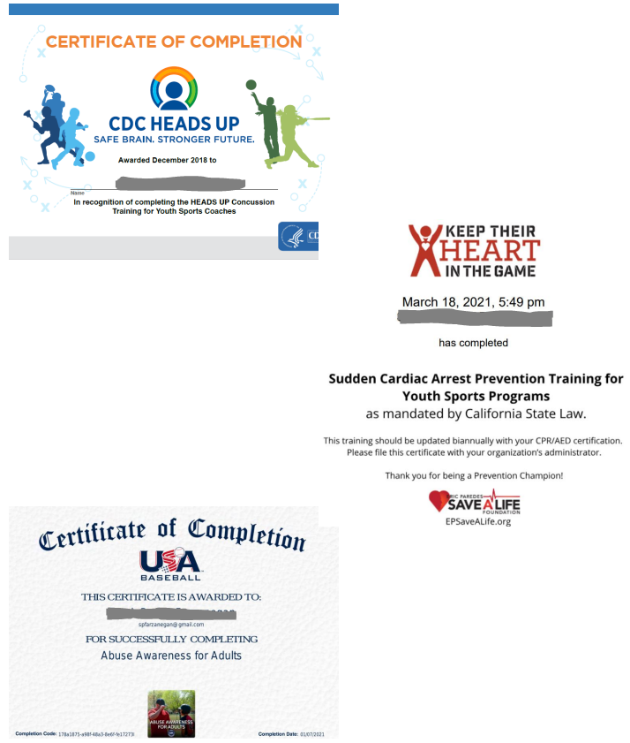

## Appendix B – Allergic Reactions, Anaphylaxis, and EpiPen Administration Instructions

[https://www.wikihow.com/Use-an-Epipen](https://nam03.safelinks.protection.outlook.com/?url=https%3A%2F%2Fwww.wikihow.com%2FUse-an-Epipen&data=02%7C01%7Cndemarce%40clarkpacific.com%7C71bc1727637b44addf4708d7a2a35e6f%7Cf32f5112ad264dc39acc481004809828%7C0%7C0%7C637156694867520021&sdata=W%2Fu2U%2F%2FpcIqc4WO2O0C0IiPcVGMzha8GrSLyJdT2pcQ%3D&reserved=0)

## Appendix C – Parent/Athlete Concussion Information

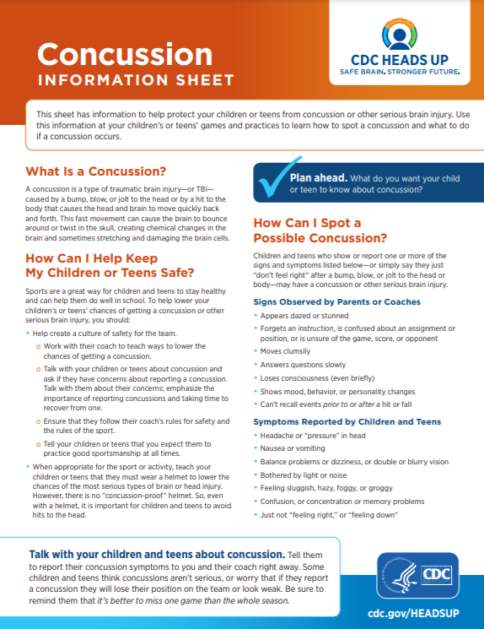

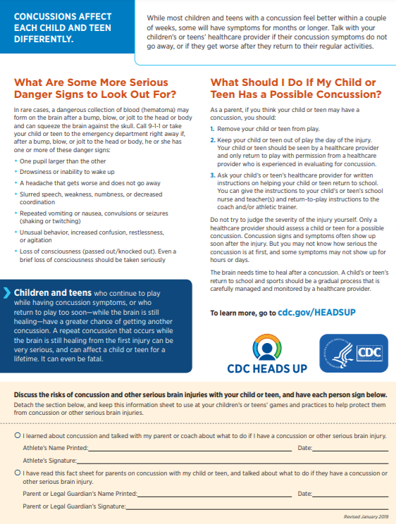

## Text Description automatically generatedAppendix D – Sudden Cardiac Arrest Prevention Information

## Appendix E – Incident/Injury Tracking Report Form

## Appendix F – Little League Accident Notification Form

<https://www.littleleague.org/downloads/accident-claim-form/>

## Appendix G – Little League Volunteer Application

<https://www.littleleague.org/downloads/volunteer-application/>

## Appendix H – Divide Little League Codes of Conduct (Player, Parent, Manager/Coach)

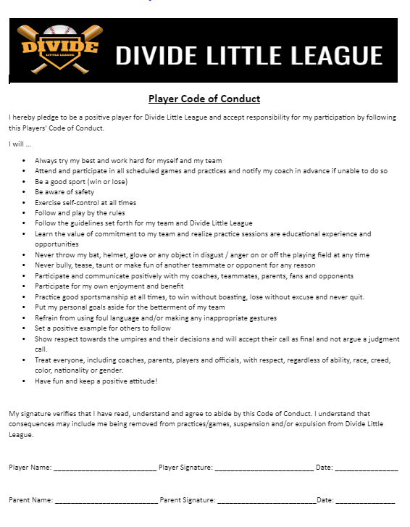

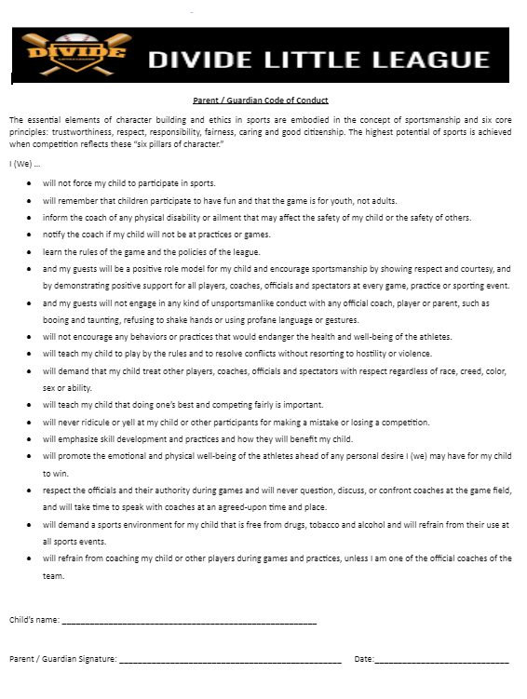

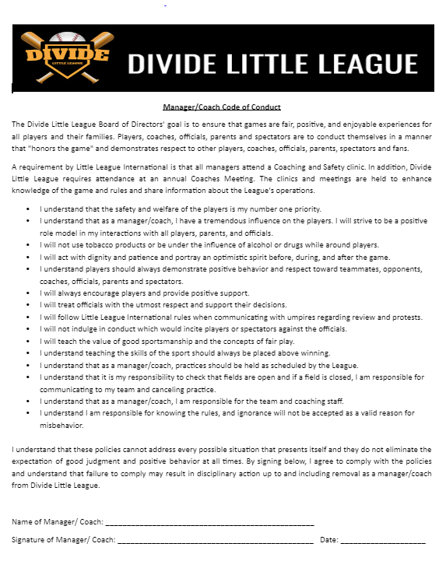

## 

## Appendix I- Medical Release Form

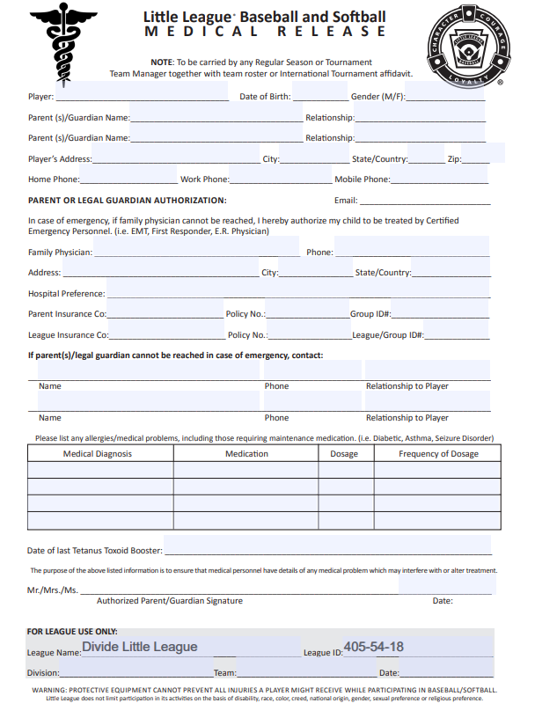

## Appendix J- Safety Clinic Flyer

**2025 Managers/Coaches Safety Clinic**

**Date**: **Monday, February 3rd, 2025**

**Time:** 6:00 p.m. – 8:00 p.m.

**Location:** TBD

**This is a MANDATORY TRAINING clinic!**

Must be attended by at least ONE Manager/Coach per team per season.

Required for all Managers and Coaches every 3 years.

This clinic meets the necessary ASAP requirements set forth by Little League Baseball, INC.

## 

## 

## 

## 

## 

## 

## 

## 

## 

## Appendix K – Big Al Baseball Online Training

Parents, Managers, and Coaches will have access to this program prior to the season starting.

<http://bigalbaseball.com/>

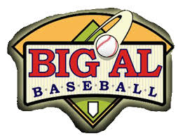

## Appendix L – Baseball/Softball Dynamic Warm-Up and Stretching Program (from University of Rochester Sports Medicine)

## Appendix M – Concussion: Signs, Symptoms and Action Plan

## Appendix N – Concession Stand Rules and Safety Tips

**Concession Stand Rules**

**1.** Adult supervision must always be in effect.

**2.** Only adults (18 years of age or older) can operate or be near the grill.

**3.** Outdoor grills will be placed in an area away from spectators.

**4.** All volunteers will wash their hands on a regular basis. (Hand Sanitizer available)

**5.** Unwrapped food must be handled with paper towels or plastic wrap.

**6.** No glass containers of any type will be sold at the concession stand.

**7.** Everything must be cleaned up and put away at the end of each shift.

**8.** A complete First-aid Kit will be kept in the concession stand.

**9.** A fire extinguisher shall be kept in the concession stand for emergency use.

**10.** A list of emergency phone numbers will be posted in the concession stand.

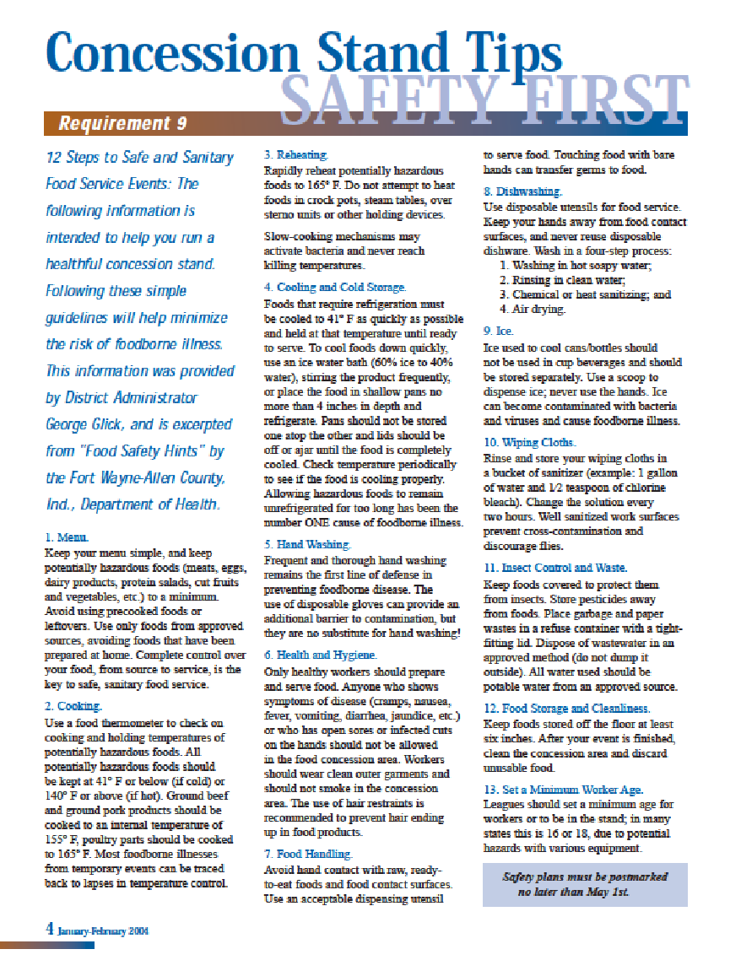

## Appendix O - Lightning Safety Procedures

**Lightning Safety and Procedures**

Divide Little League follows Little League policy regarding lightning safety with the following guidelines:

1. Watch for developing or approaching storms; use all resources (web, TV, radio, etc.) to determine the risk level.
2. At the first sound of thunder or visible lightning - **CLEAR THE FIELD!**

A thunderstorm can cast lightning up to 10 miles from the edge of the storm, or about as far as the sound of thunder can carry.

**WHAT TO DO:**

* Go to a large, enclosed building, if one is nearby.
* Go to metal-top cars, with windows rolled up, if no enclosed building is available.
* Complete a check of the facility for anyone still outdoors.

**WHAT NOT TO DO:**

* Do NOT allow players to remain in the dugouts OR spectators to stay in the stands.
* Do NOT carry metal items (like bats) or walk beside metal fences.
* Do NOT go to an open-sided shelter; it is not adequate and should not be used.

**Resuming activities:**

* Wait at least 30 minutes after the last lightning strike/peal of thunder before returning to play.
* Do not leave the facility until directed; wait at designated location(s) at the field until the game is postponed or canceled.
* Make sure all players are accounted for and leave with the approved person(s).

If someone is struck by lightning:

* Lightning victims do not carry an electrical charge, are safe to handle, and need immediate medical attention.
* Call for help. Have someone call 9-1-1 or your local ambulance service. Give first aid. Begin CPR if necessary.
* If possible, move the victim to a safer place.

For more information and tips on lightning safety, visit NOAA’s website:

<http://elcosh.org/document/4154/d001459/osha-noaa-fact-sheet%3A-lightning-safetywhen-working-outdoors.html>

**Parents, coaches, umpires and all volunteers - please help enforce this policy. Our children’s lives may depend on YOU!**

## Appendix P – References, Links and Websites

Concussion Safety: [https://www.cdc.gov/headsup/youthsports/training/index.html](https://nam03.safelinks.protection.outlook.com/?url=http%3A%2F%2Fsend.bluesombrero.com%2Fwf%2Fclick%3Fupn%3DowqKfIc-2BG2i-2B6rq7MKAe-2B-2BqfNyM99GY5ZJxew9uCE8nAE16gQL-2BbysMUpn4wvHGXXGCyqvg-2FWFPWRqQUtetIflO-2F8ytBQe-2BE9WDU39TVhXA-3D_nSMj6r2ZXHEFqbdimbbsQa108OMpPhd3VSVsSLDQbzsWhLgtWgCAAYq9swnQ9Ce0oxCskwHJi6n98nq3CbfFwvWxKyCt1RbgpjRMvT7-2B2eKpOnwDYh7mwzKkx2BaEpzQcJCmgwoETsF1SS548PO4qyiKn6yPCKBNJ0EZ-2BHCWd24x3xx2iI6FKznB6dqCtgWM3lmoVZbaO7rKDHgdTc8r50xdqKU7-2B-2FJuKDlN8YIsvlZ1ILLVV6sSooA5Kr1aePoOb7Ot-2B4lTSCFHwwO6FUcs5Q-3D-3D&data=02%7C01%7Cndemarce%40clarkpacific.com%7C52e1f8e9819745170ed008d78234d092%7Cf32f5112ad264dc39acc481004809828%7C0%7C1%7C637121035728083593&sdata=rlc58uXJYuEGGZQN9RYMlm9ZsNqm2Trr3YkuhVnHyS8%3D&reserved=0)

US Center for Safe Sport (Abuse Awareness for Adults):

<https://www.littleleague.org/player-safety/child-protection-program/safesport-resources-parents/>

USA Little League Baseball Bats: <https://www.littleleague.org/playing-rules/bat-rules/>

Little League Rulebook App: <https://www.littleleague.org/playing-rules/little-league-rulebook-app/>

California District 54: <https://www.ca54littleleague.com/Default.aspx?tabid=1548924>

El Dorado Hills Little League: <https://www.edhll.com/>

Lightning Safety: <https://www.nws.noaa.gov/om/marine/factlightning.pdf>

Concession Stand Tips:

<https://ll-production-uploads.s3.amazonaws.com/uploads/2018/01/09-Concession-Safety.pdf>

Modifying Helmets/Additional Attachments:

<https://www.littleleague.org/playing-rules/modifying-helmets-with-additional-attachments/>

Big Al Training: <http://bigalbaseball.com/>

1. *Makhni EC, Morrow ZS, Luchetti TJ, et al. Arm Pain in Youth Baseball Players: A Survey of Healthy Players. AJSM 43:1, 2015.*
2. *Cusimano MD, Zhu A. Systematic Review of Traumatic Brain Injuries in Baseball and Softball: A Framework for Prevention. Front. Neurol., 30 October 2017.* [*https://doi.org/10.3389/fneur.2017.00492*](https://doi.org/10.3389/fneur.2017.00492)